EXP NO 4: CREATE A SIMPLE CLOUD SOFTWARE APPLICATION FOR CAR BOOKING RESERVATION SYSTEM USING ANY CLOUD SERVICE PROVIDER TO DEMONSTRATE SAAS.
DATE:
AIM:
To Create a simple cloud software application for Car Booking Reservation System
using any Cloud Service Provider to demonstrate SaaS.
PROCEDURE:
step1: Go to zoho.com.
step 2: Log into the zoho.com.
step 3: Select one application step.
step4: Enter application name as Car Booking Reservation System.
step 5: Created new application as Car Booking Reservation System.
step 6: Select one form
step 7: The software has been created.

IMPLEMENTATION:
STEP1: GOTO ZOHO.COM
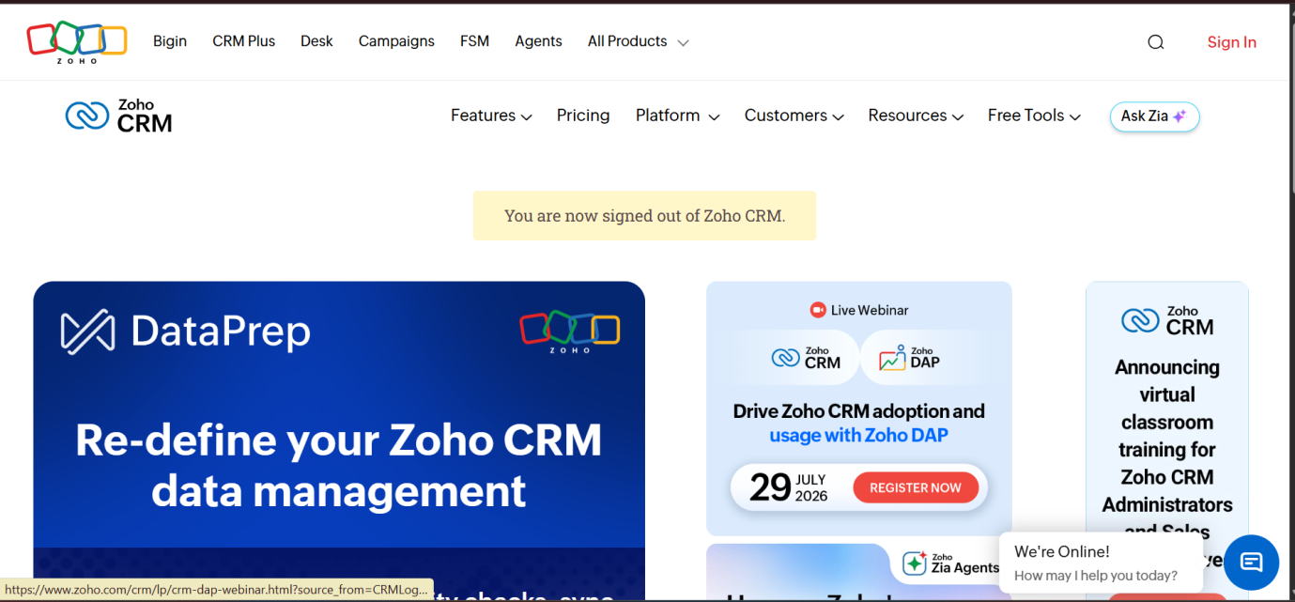

STEP 2: LOG INTO THE ZOHO.COM.
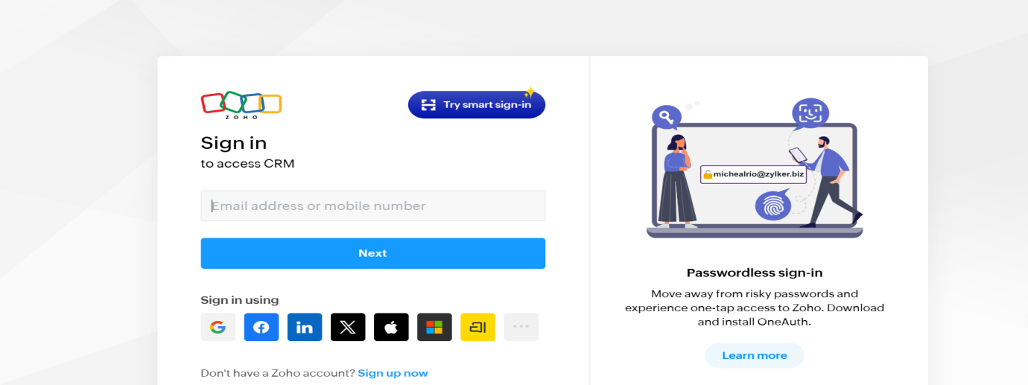
STEP 3: SELECT ONE APPLICATION STEP.
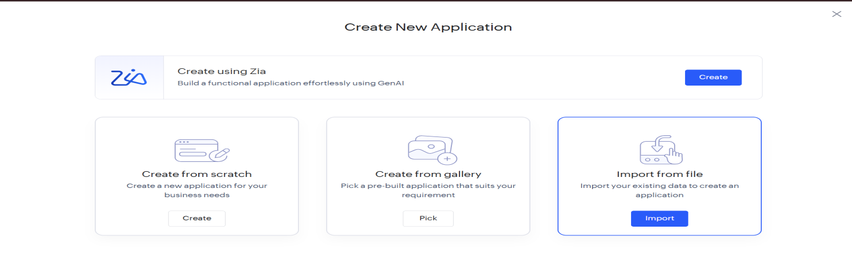
STEP4: ENTER APPLICATION NAME AS CAR BOOKING RESERVATION SYSTEM.
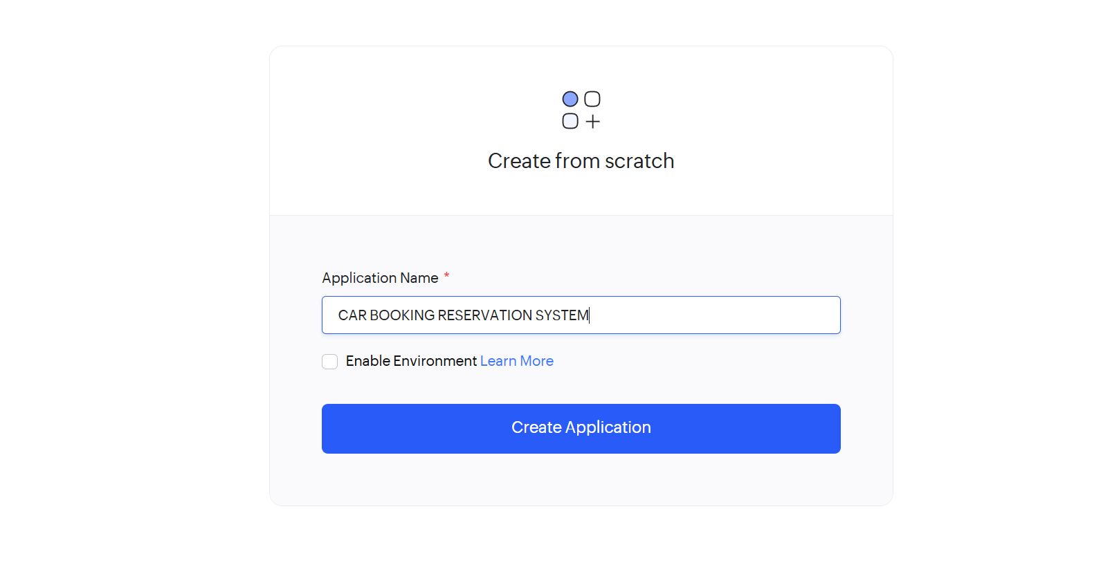

STEP 5: CREATED NEW APPLICATION AS CAR BOOKING RESERVATION SYSTEM.

STEP 6: SELECT ONE FORM
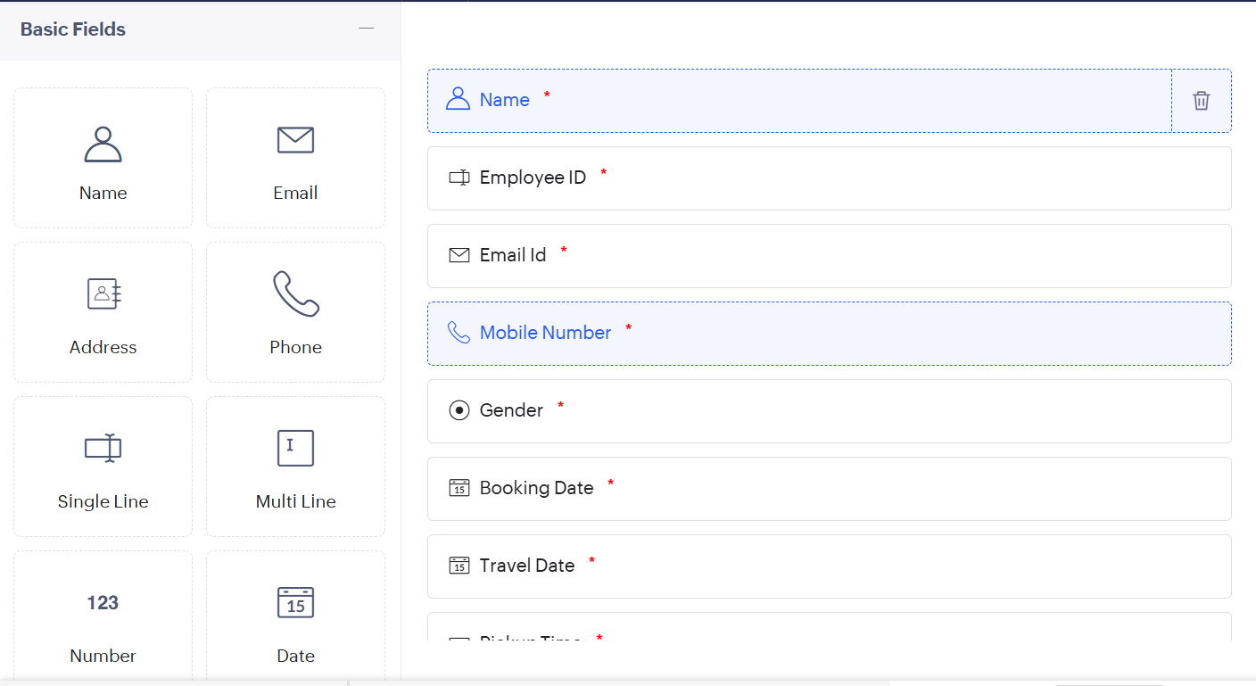
STEP 7: THE SOFTWARE HAS BEEN CREATED.
